
RAMAIAH
INSTITUTE OF TECHNOLOGY
USN | 1 | M | S

(Autonomous Institute, Affiliated to VTU)
Bangalore – 560 054

MAKEUP EXAMINATIONS – MAY/JUNE 2017

Course & Branch | : | B.E : Information Science and Engineering | Semester | : | IV
Subject | : | Design and Analysis of Algorithms | Max. Marks | : | 100
Subject Code | : | IS414 | Duration | : | 3 Hrs

Instructions to the Candidates:
- Answer one full question from each unit.

 |  | UNIT - I
1. | a) | Define an algorithm. Describe the sequence of steps in designing and analyzing an algorithm. | CO1 | (10)
 | b) | Describe the general plan for analyzing the efficiency of nonrecursive algorithms. Find the time efficiency class of the algorithm given below.  ALGORITHM GE(A[0….n-1,0….n])  for i←0 to n-2 do  for j←i+1 to n-1 do  for k←i to n do  A[j,k] ←A[j,k]]-A[i,k]*A[j,i]/A[i,i] | CO1 | (10)
2. | a) | Explain the O, Ω and Θ notations. Prove that ½ n (n-1)є Θ(n²) and 3n³ + 2n² є O(n³). | CO1 | (08)
 | b) | For the given algorithm, set up a recurrence relation for its basic operation and solve it by using backward substitution method.  ALGORITHM BinRec(n)  //Input: A positive decimal integer n  //Output: The number of binary digits in n’s binary representation  if n=1 return 1  else return BinRec()+1 | CO1 | (06)
 | c) | Design an algorithm to perform linear search on an array. Determine its best, worst and average-case time efficiencies. | CO1 | (06)
 |  | UNIT - II
3. | a) | Write quicksort algorithm and analyze its average-case efficiency. | CO1 | (10)
 | b) | Consider the problem of searching for genes in DNA sequence using Horspool’s algorithm. A DNA sequence is represented by a text on the alphabet {A, C, G, T} and the gene or gene segment is the pattern.  i) Construct the shift table for the following gene segment of the chromosome: TCCTATTCTT  ii) Apply Horspool’s algorithm to locate the pattern in the following DNA sequence:  TTATAGATCTCGTATTCTTTTATAGATCTCCTATTCTT. | CO2 | (10)
4. | a) | Write an algorithm to find the height of binary tree. Analyze and compare between the number of additions and comparisons made in computing the height of a binary tree. | CO1 | (10)
 | b) | What is brute force method? Discuss the working of bubble sort algorithm considering the following list: 89, 45, 68, 90, 29, 34, 17. | CO1 | (10)
 |  | UNIT - III
5. | a) | Differentiate between dynamic programming and divide and conquer method with an example. | CO1 | (05)
 | b) | What is knapsack problem? Obtain solution for the following knapsack problem using greedy method. Given knapsack capacity W=30. | CO2 | (05)
  Item | Weight | Value
  1 | 18 | 25
  2 | 15 | 24
  3 | 10 | 15
 | c) | Write the formula to find the shortest path using Floyd’s approach. Use Floyd’s method to solve the following all pairs shortest path problem. | CO2 | (10)
  0 |  | 3
  2 | 0
   | 7 | 0 | 1
  6 |  |  | 0
6. | a) | Consider the problem of scheduling n jobs of durations t1, t2,……tn for execution by a single processor. The jobs can be executed in any order, one job at a time. You want to find a schedule that minimizes the total time spent by all jobs in the system. (The time spent by one job in the system is the sum of the time spent by this job in waiting plus the time spent on execution)  i) Design a greedy algorithm for this problem.  ii) Does the greedy algorithm always yield an optimal solution? Justify. | CO2 | (10)
 | b) | What is minimum spanning tree. Write Prim’s algorithm to find a minimum spanning tree of the graph. Analyze its time complexity. | CO1 | (10)
 |  | UNIT – IV
7. | a) | Write the pseudo code for performing Depth First Search. Traverse the following Graph using Depth First Search and Breadth First Search.  f  b  c  g  d  a  e | CO1 | (10)
 | b) | Using decrease and conquer technique, find J(40) in Josephus problem. | CO2 | (05)
 | c) | Construct 2-3 tree for the list C, O, M, P, U, T, E, R. | CO2 | (05)
8. | a) | Define Topological sort. Apply the source removal method to solve the topological sorting problem for the digraph given in the following graph.  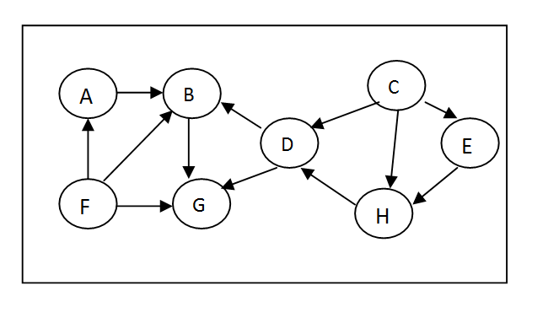 | CO2 | (06)
 | b) | Develop an algorithm to perform insertion sort. Specify the algorithm technique used. Apply the same to sort the list I,N,S,E,R,T,I,O,N. | CO1 | (08)
 | c) | What is an AVL tree? Construct an AVL tree by inserting the elements 1,2,3,4,5,6 successively, starting from an empty tree. | CO2 | (06)
 |  | UNIT- V
9. | a) | Write short notes on P, NP and NP-complete problems. | CO3 | (06)
 | b) | Obtain the optimal tour for the travelling sales person problem of the cost matrix given below: | CO2 | (10)
   | 1 2 3 4 5
  1  2  3  4  5 | ∞ 20 30 10 11  15 ∞ 16 4 2  3 5 ∞ 2 4  19 6 18 ∞ 3  16 4 7 16 ∞
 | c) | What is branch and bound algorithm technique? How is it different from backtracking? | CO1 | (04)
10. | a) | Define heap. With an example, explain sorting using heap structure. Give the pseudocode for bottom up heap construction. | CO1 | (10)
 | b) | Design C/C++ code to implement N-Queens problem using backtracking technique and provide the sample output for the same. | CO1 | (10)
****************

